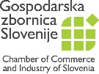 | 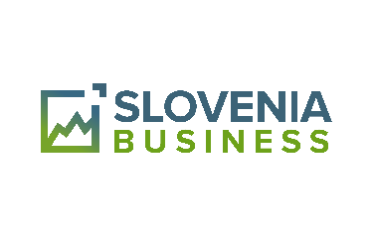 |  | 

Event: | VIETNAM – SLOVENIA Interactive B2G in B2B Meeting
Date: | Monday, October 9, 2023
Time: | Ljubljana @GZS, Dimičeva 13, Hall B, 1st Floor

List of Vietnames companies
 | Company | Delegate
 | HANOI BEER ALCOHOL AND BEVERAGE JSC | Mr. Ngô Quế Lâm, CEO  Mr. Nguyễn Quang Thanh, Chief of Administrative Office
 | VIETNAM MARITIME CORPORATION | Mr. Lương Bình Minh, Head of Supervisor Board
 | VIMC SHIPPING COMPANY | Mr. Đào Trọng Sử, Deputy Director
 | VIETNAM ELECTRICITY CORPORATION | Mr. Nguyen Tai Anh, Deputy Director General  Mr. Dao Ngoc Long  Mr. Trinh Cuong  Mr. Hoang Giang
 | BEE LOGISTICS CORPORATION | Mr. Le Tran Nhat Phuong, Deputy Director General
 | GP HOLDING | Mr. Nguyen Chi Thanh, President  Mr. Nguyen Thanh Cong, Deputy Director
 | HANOI MECHANICAL COMPANY | Mr. Nguyen Ngoc Hung, CEO
 | VIETNAM MOTORS AND AGRICULTURAL MACHINERY CORPORATION | Mr. Nguyen Khac Hai, Chairman

